Supplementary Materials

Table S1. This table shows the Political-administrative division of the metropolitan area, Chile, in which this work was carried out. Our Work is focused on Municipality analysis. Data obtained from Subsecretaria de Desarrollo Regional y Administrativo.

Province | Capital | Municipality
Chacabuco | Colina | 1.- Colina
Chacabuco | Colina | 2.- Lampa
Chacabuco | Colina | 3.- Tiltil
Cordillera | Puente Alto | 4.- Pirque
Cordillera | Puente Alto | 5.- Puente alto
Cordillera | Puente Alto | 6.- San José de Maipo
Maipo | San Bernardo | 7.- Buin
Maipo | San Bernardo | 8.- Calera de Tango
Maipo | San Bernardo | 9.- Paine
Maipo | San Bernardo | 10.- San Bernardo
Melipilla | Melipilla | 11.- Alhué
Melipilla | Melipilla | 12.-Curacaví
Melipilla | Melipilla | 13.- María Pinto
Melipilla | Melipilla | 14.-Melipilla
Melipilla | Melipilla | 15.-San Pedro
Santiago | Santiago | 16 Cerrillos  17 Cerro Navia  18 Conchalí  19 El Bosque  20 Estación Central  21 Huechuraba  22 Independencia  23 La Cisterna  24 La Granja  25 La Florida  26 La Pintana  27 La Reina  28 Las Condes  29 Lo Barnechea  30 Lo Espejo  31 Lo Prado  32 Macul  33 Maipú  34 Ñuñoa  35 Pedro Aguirre Cerda  36 Peñalolén  37 Providencia  38 Pudahuel  39 Quilicura  40 Quinta Normal  41 Recoleta  42 Renca  43 San Miguel  44 San Joaquín  45 San Ramón  46 Santiago  47 Vitacura
Talagante | Talagante | 48 El Monte  49 Isla de Maipo  50 Padre Hurtado  51 Peñaflor  52 Talagante

Table 2. Population and socioeconomic level of the communes under analysis. This table shows the socioeconomic level of the population of the 10 communes with greater contagion rate in the metropolitan region. The classification of the socioeconomic groups was obtained from the National Institute of Statistics of Chile (INE), SES: Socioeconomic status.

Municipality | Population | SES
Puente Alto | 568.106 | Middle
Santiago | 404.495 | Middle
La Florida | 366.916 | Middle
Peñalolén | 241.599 | Middle
Maipú | 521.627 | Middle
Recoleta | 157.851 | lower-middle
Quilicura | 210.410 | lower-middle
Independencia | 100.281 | lower-middle
San Bernardo | 334.248 | lower-middle
La Pintana | 177.335 | low

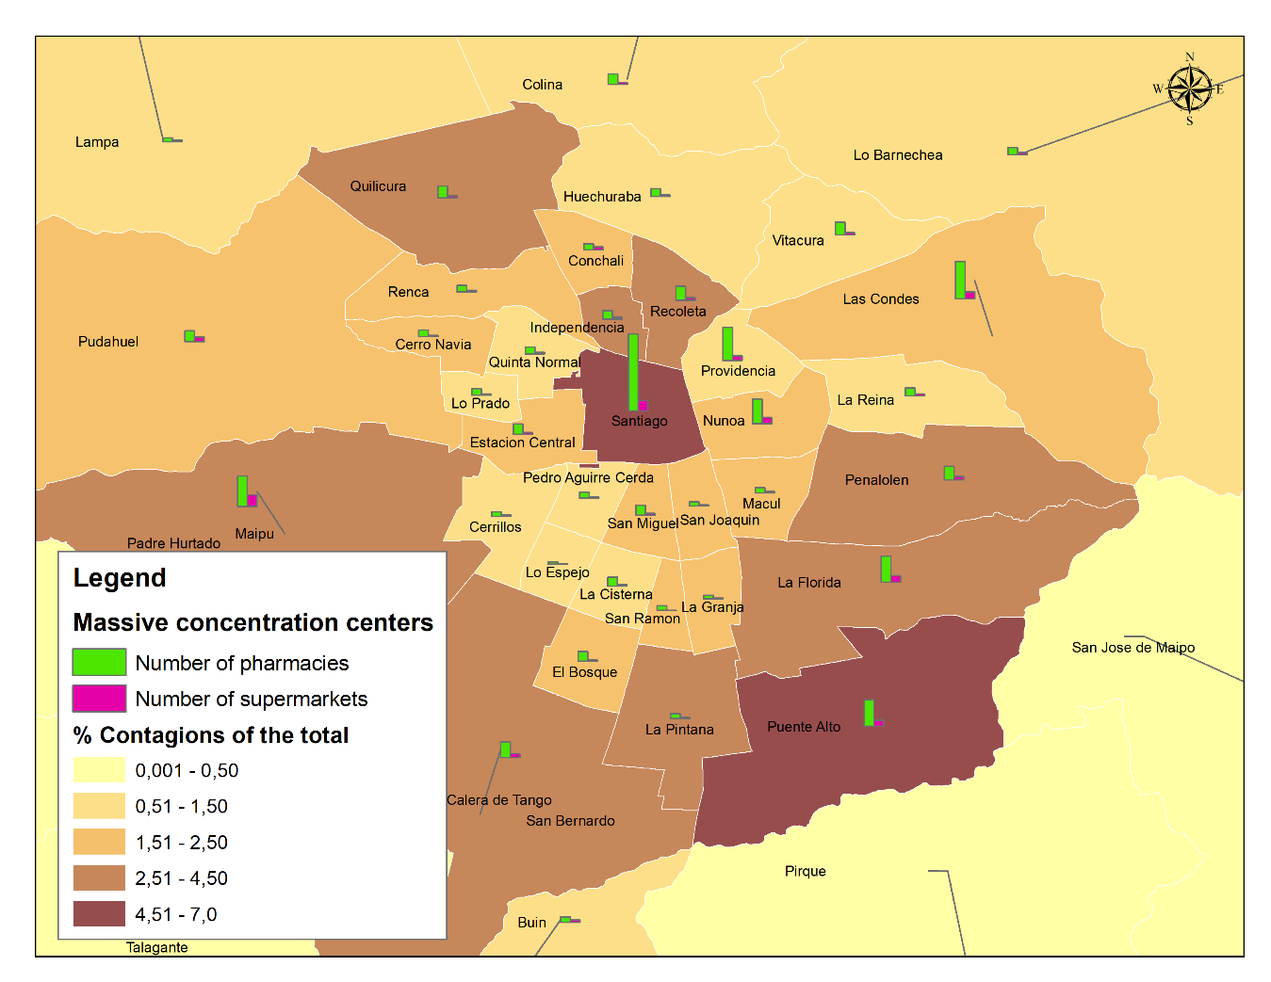
Figure. S1. Relationship between contagion rate and centers that generate agglomeration of people. This map represents the relationship between the number of centers of mass concentration and the contagion rate by commune in relation to the regional total. It can be seen that the communes with the greatest number of pharmacies and supermarkets are those that register the greatest number of infections. Since they are the communes with the largest populations, the implementation of basic supply services is concentrated in these communes. This population makes daily purchases of supplies, since they do not have the resources to make large monthly purchases, as do the populations of the more affluent communes. The data were obtained from the Census database 2017, the Chilean Association of Pharmaceutical Chemists and the Chilean Supermarkets Association.

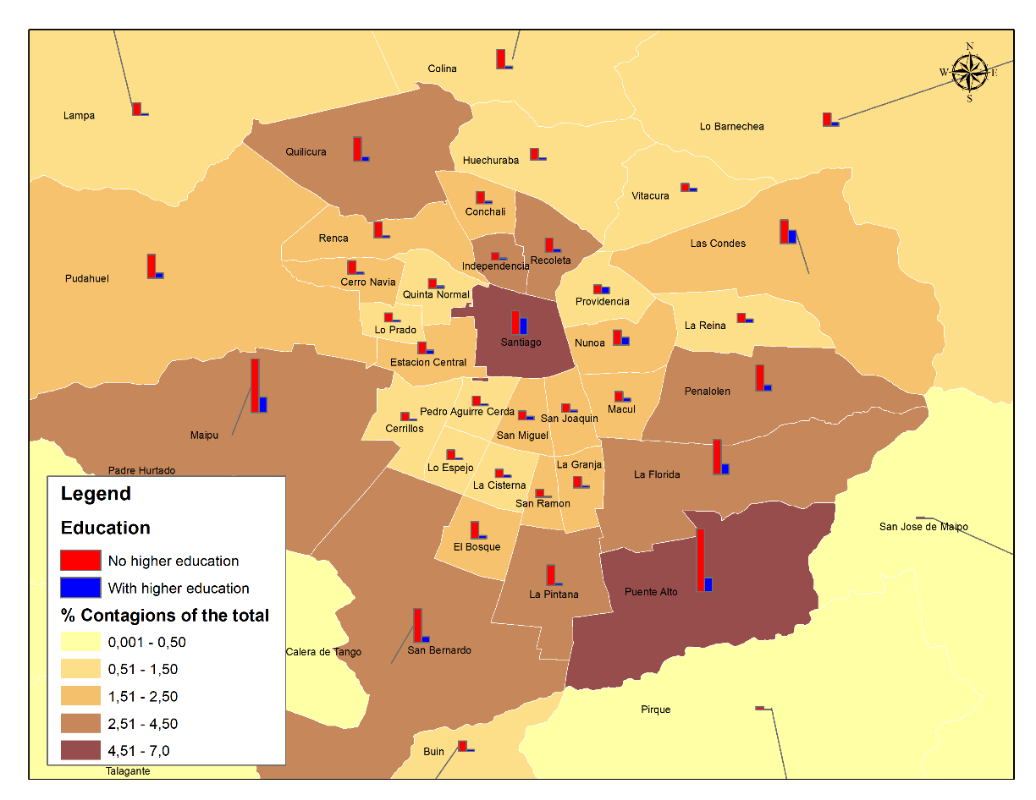
Figure. S2. Ratio of population without and with higher education, and contagion rate by commune in relation to the regional total. The communes that register the highest percentage of population without higher education are those that register the highest contagion, which may be due to the type of occupation they carry out, implying transfers that expose them to the risk of contagion, versus people with higher education who, in their majority, can carry out teleworking, decreasing the risk of contagion.

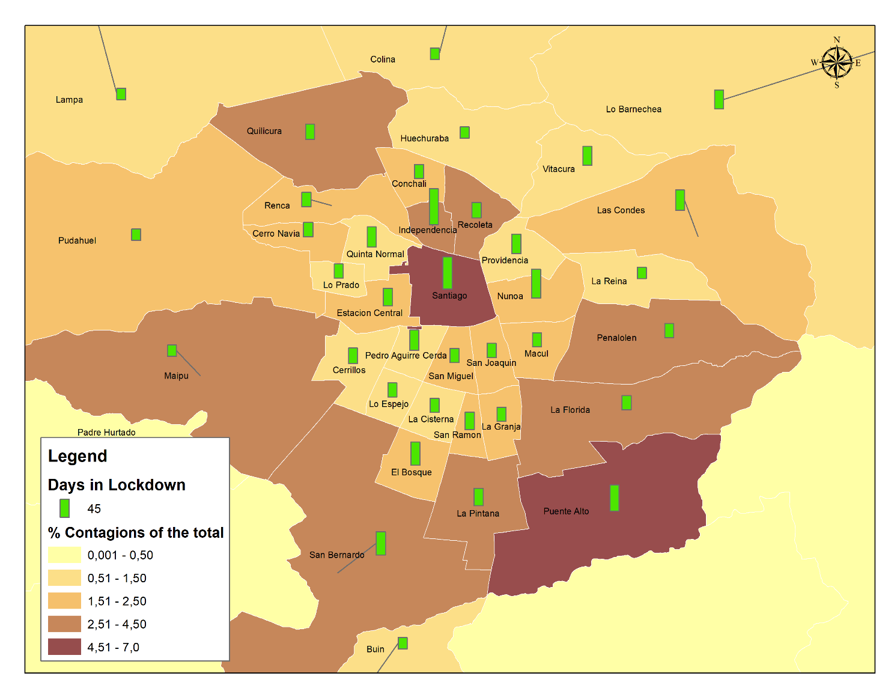
Figure. S3. Relationship between the number of days under lockdown and the contagion rate per commune in relation to the regional total. The communes with the highest number of infections are those that have been under lockdown the longest, which indicates that the measure applied in a reactive way is not effective.

Figure. S4. Daily New Cases. The communes of Puente Alto and Pedro Aguirre Cerda, even though they were lockdown during April, the growth of their contagion rate continued to increase, this can be explained given that there was already a significant increase during the initial two weeks of the pandemic.

